**BUSINESS INTELLIGENCE**

Business intelligence tools, such as Power BI and Excel, allow users to do interactive visualizations with self-service business intelligence capabilities. Our goal is to allow end users to create reports and dashboards, without having to depend on information technology staff. We loaded data from the data warehouse and used visualization charts, such as card, donut chart, stacked bar chart, gauge, line chart, and tree map, to answer the business questions. The sample questions and solutions are as follows:

**Know Our Customer:**

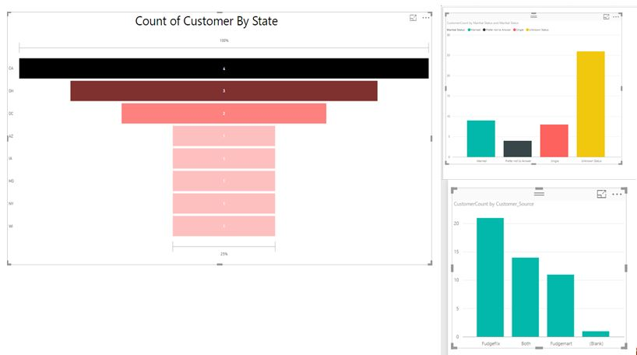

* California state has the highest number of customers
* Distribution of customers based on marital status: Maximum number of customers prefer not to state their marital status
* FudgeMart has the maximum amount of customers

**Customer Review:**

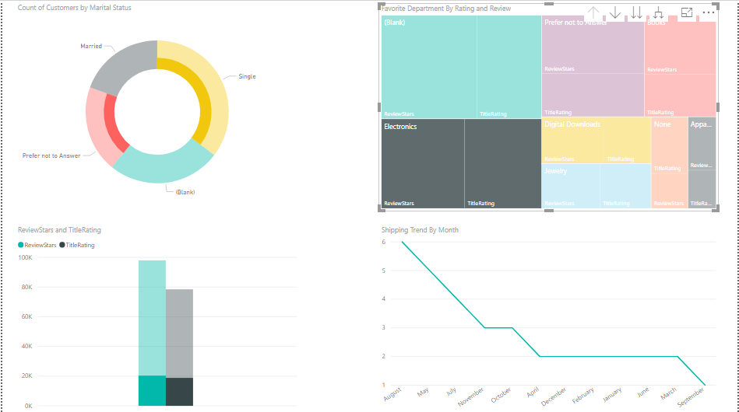

* The favorite department of customers is Electronics followed by Books, Digital Downloads and Apparels
* Electronics are majorly purchased by Single Customers
* Apparels are majorly purchased by Married Customers
* Highest Shipping Done was in the month of August

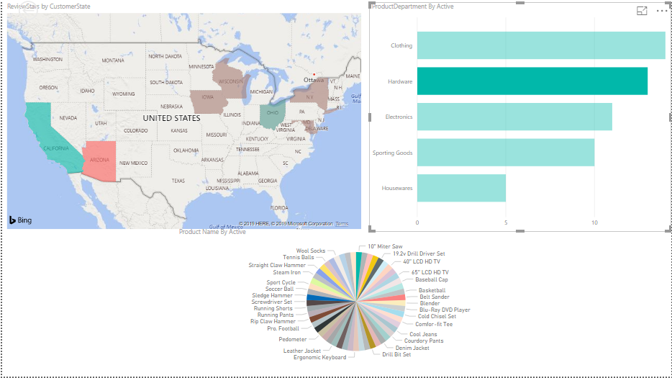

Interactive Dashboard representing State Distribution according to Departments and Products purchased

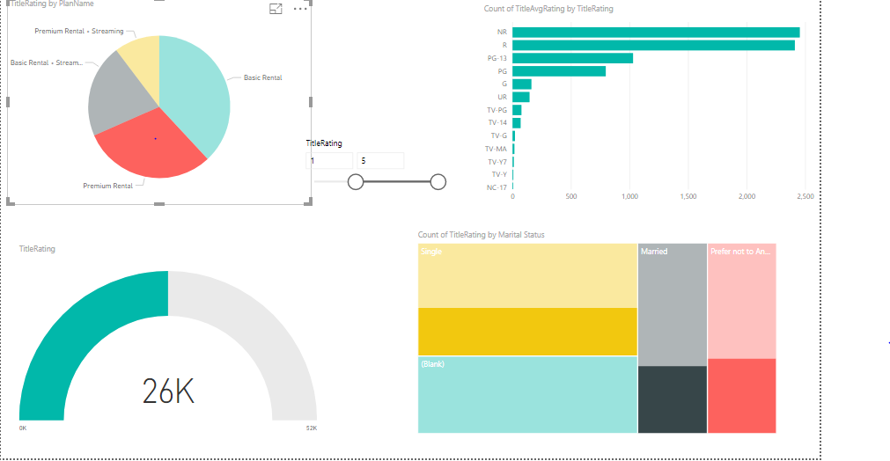

Interactive Dashboard representing the Title Trends with rating

* Title Rating: NR has the highest Average Rating
* Basic Rental plan is the most purchased plan according to the marital status and average title rating

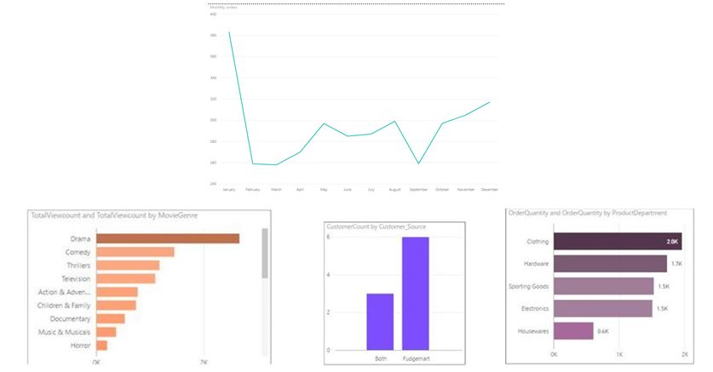

* The favorite department of customers is Electronics followed by Books, Digital Downloads and Apparels
* Drama is the highest trending title

**Delivery Efficiency:**

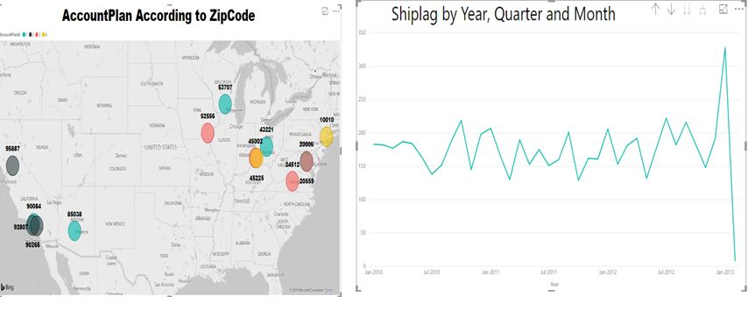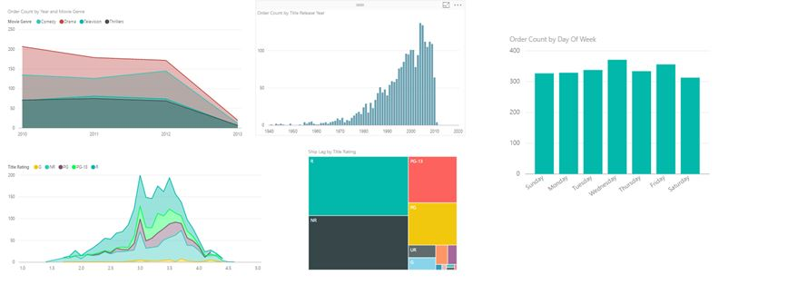

* Movies under the Drama genre have been ordered the most over the years, followed by Comedy, Television and Thrillers
* Ship Lag for Drama has been highest over the years, so we need to understand if this is influenced by Order count, or another external factor
* Order count has reduced drastically since 2011, due to other stiff competitors
* We also see that the highest orders are received on Wednesdays, and are ordered comparatively lesser on weekends
* Order count of television series is comparatively lesser than movies, hence they need to look at ways to improve television series